Project Design Phase-II
Data Flow Diagram & User Stories

Date | 18 June 2026
Team ID
Project Name | ShopEZ-E-commerce-Application
Maximum Marks | 4 Marks

Data Flow Diagrams:
A Data Flow Diagram (DFD) is a traditional visual representation of the information flows within a system. A neat and clear DFD can depict the right amount of the system requirement graphically. It shows how data enters and leaves the system, what changes the information, and where data is stored.
Example:
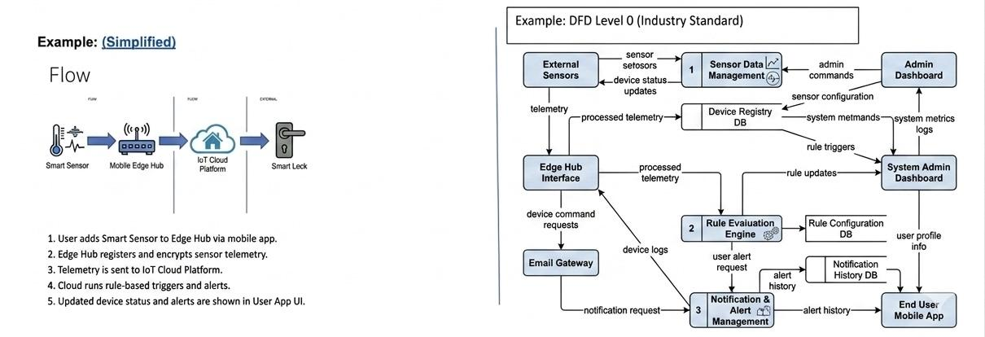

User Stories
Use the below template to list all the user stories for the product.
User Type | Functional Requirement (Epic) | User Story Number | User Story / Task | Acceptance criteria | Priority | Release
Customer (Mobile user) | Registration | USN-1 | As a user, I can register for the application by entering my name, email, and password. | I can access my account / dashboard | High | Sprint-1
Customer (Mobile user) | Login | USN-2 | As a user, I can log into the application securely using my email and password. | I can receive confirmation email & click confirm. | High | Sprint-1
Customer (Web user) | Dashboard | USN-3 | As a user, I can view a live market dashboard displaying current stock prices and trends. | Dashboard successfully fetches and displays real-time data via API polling. | High | Sprint-1
Customer (Web user) | Simulated Trading | USN-4 | As a user, I can register for the application through Gmail | Virtual wallet balance accurately deducts/adds funds, and trade logs to history. | High | Sprint-1
Customer (Web user) | Portfolio | USN-5 | As a user, I can view my active stock holdings alongside my current profit or loss. | UI displays accurate calculations (green for profit, red for loss) based on current vs buy price. | Medium | Sprint-1
Customer (Web user) | Admin Dashboard | USN-6 | As an admin, I can view a dashboard showing total active users and overall platform trade volume. | Admin dashboard loads successfully with accurate aggregate data from the database. | Medium | Sprint-1

